BEEE EVALUATION

**Circuit Diagram**:

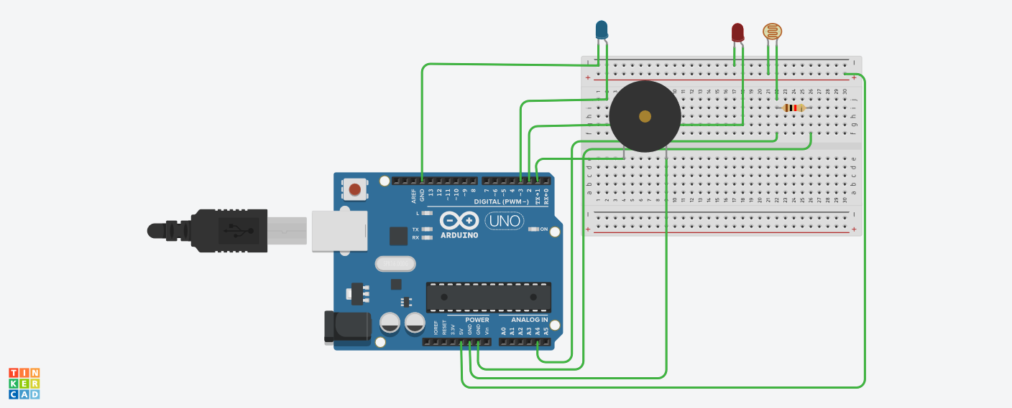

**Theory:**

Concepts Used:

1.Coding Arduino.

2.Working with breadboard.

**Learning & Observations**:

Learned the use of breadboard.Understood the use of LDR. Understood the working of Arduino.

We can make many useful devices like drones using Arduino.

**Problems & Troubleshooting**

Ldr was little tricky ,but it was fun.

**Precautions**

1. Declare pins used .
2. Connect ldr properly.

**Learning Outcomes**

Learned the use of ldr.

**Working**

when gift box is opened light falls in it,the circuit gets activated and the buzzer beeps.

The LED’s blink alternatively.

LDR gets activated in light and in dark it is inactive.